TEACHER COPY – PRACTICAL ASSESSMENT TASK
Task Name: | Mid-Sem Skills Assessment Part A | Date: | 08/10/2024
Course Name: | Cybersecurity - Ops | Course Code: | INTE-2257
Student Name: | Vu Nguyen | Student Number: | S4010423

Assessment Information
INTE2557: Cybersecurity - Ops
Mid-Semester: Skills Assessment Part A

Background / Scenario
HyperText Transfer Protocol (HTTP) is an application layer protocol that presents data via a web browser. With HTTP, there is no safeguard for the exchanged data between two communicating devices.
With HTTPS, encryption is used via a mathematical algorithm. This algorithm hides the true meaning of the data that is being exchanged. This is done through the use of certificates that can be viewed later in this lab.
Regardless of HTTP or HTTPS, it is only recommended to exchange data with websites that you trust. Just because a site uses HTTPS does not mean it is a trustworthy site. Threat actors commonly use HTTPS to hide their activities.

Introduction
You have been hired as a junior security analyst. In this practical assessment, you will explore and examine HTTPS from a Dridex malware infection traffic using Wireshark.
You will have access to the internet to learn more about the events.
The tasks below are designed to provide some guidance through the analysis process.
You will practice and be assessed on the following skills:
- Locate and evaluate event alerts using Wireshark.
- Use protocols filter to examine malware infection.
- Use VirusTotal to upload and verify threat existence.

Content for this assessment was obtained from http://www.malware-traffic-analysis.net/ and is used with permission. We are grateful for the use of this material.

Required Resources
- Host computer with at least 8GB of RAM and 45GB of free disk space
- Latest version of Oracle VirtualBox
- CyberOps Workstation virtual machine requires 4GB of RAM using 25GB disk space
- Internet access
- If you choose to use the lab computer, you need to bring your own HDD drive with the downloaded CyberOps Workstation virtual machine

Instructions

The skills assessment is a demonstration of your skills and knowledge in completing the labs work and cisco networking academy. The assessment will be performed and completed on-campus session, all tasks need to be checked and signed by the assessor/teacher.

Part 1: Preparing Linux & Wireshark Environment
In this part, you will demonstrate the presentation listed in CyberOps Workstation VM.

Task 1: Download and upload PCAP in Wireshark (5 Points)
      - Log into CyberOps Workstation VM using the username analyst and password cyberops.

      - Open a browser and download pcap and key log file that be used for this practical assessment. Mid-Sem PCAP Files
Warning: The pcap used for this tutorial contains Windows-based malware. There is a risk of infection if using a Windows computer. We recommend you review this pcap in a non-Windows environment like BSD, Linux or macOS if at all possible

      - Unzip the ZIP file, there would be 2 files available Wireshark-tutorial-KeysLogFile.txt and Wireshark-tutorial-on-decrypting-HTTPS-SSL-TLS-traffic.pcap use the password infected.
Note: Collect screen shot evidence in performing / completing the tasks.

Before proceeding, verify that’s Tasks 1 A, B & C are demonstrated with the assessor/teacher.
Instructor Sign-off Tasks 1: ______________________
Points: _________ of 5

Task 2: Gather basic information.
      - Run the Wireshark-tutorial-on-decrypting-HTTPS-SSL-TLS-traffic.pcap. Show/Demonstrate that the correct PCAP file are loaded. (5 Points)

      - Show the lists of the alerts on the https and tls by using the commands (http.request or tls.handshake.type eq 1)and(ssdp). (5 Points)

      - Show the lists of the HTTP & TLS protocol source IP addresses and destination IP addresses involved. (5 Points)
Sources IP address: 10.4.1.101
External IP addresses: 13.107.3.128, 40.122.160.14, 94.103.84.245, 94.103.84.245
Note: Collect screen shot evidence in performing / completing the tasks.
Type your answers here.
Before proceeding, verify that’s Tasks 2 A, B & C are demonstrated with the assessor/teacher.
Instructor Sign-off Tasks 2: ______________________
Points: _________ of 15

Part 2: Learn about the Malware
In this part, you will demonstrate more about the malware.

Task 1: Infected host
      - Identify the host that has been infected by the malware by identifying the IP address and file infected downloaded. (5 Points)
Host IP Address: 10.4.1.101
Infected File Name: invest_20.dll

      - Locate the website that has been used in downloading the malware that infected the host. (5 Points)
Website: foodsgoodforliver.com
Note: Go to HTTP Protocol

      - Demonstrate the web traffic using HTTP stream to verify the HTTP Get request from the website. (5 Points)
Note: Collect screen shot evidence in performing / completing the tasks.
Type your answers here.
Before proceeding, verify that’s Tasks 3 A, B & C are demonstrated with the assessor/teacher.
Instructor Sign-off Tasks 2: ______________________
Points: _________ of 15

Task 2: Identifying and exporting Malware
      - Export Objects in the HTTP and save the file as invest_20.dll to determine the hash. (15 Points)
Note: Collect screen shot evidence in performing / completing the tasks.

      - Determine and record the SHA256 hash for the downloaded files that probably infected the computer. Run the file name invest_20.dll and determine the SHA 256 hash. (15 Points)
Note: Collect screen shot evidence in performing / completing the tasks.

      - Navigate to www.virustotal.com input the SHA256 hash that you have determine if these were detected as malicious files. Demonstrate your findings, such as file type and size, other names, and target machine. (15 Points)
SHA256: 31cf42b2a7c5c558f44cfc67684cc344c17d4946d3a1e0b2cecb8eb58173cb2f
Note: Collect screen shot evidence in performing / completing the tasks.

Before proceeding, verify that’s Tasks 2 – A, B & C are demonstrated with the assessor/teacher.
Instructor Sign-off Tasks 2B: ______________________
Points: _________ of 45

Part 3: Report Your Findings
Summarizes your findings based on the information you have gathered from the previous parts, be brief and concise in your report. (10 Points)
From my finding, the IP Address 10.4.1.101 is infected after downloading a file named invest_20.dll. The file is from an external server 40.122.160.14 which connect to a website called foodsgoodforliver.com. The file’s SHA 256 hash is 31cf42b2a7c5c558f44cfc67684cc344c17d4946d3a1e0b2cecb8eb58173cb2f. And it was verified and identified as a Trojan virus on Virus Total

Part 4: Collection of Evidence
Complete the Table of Evidence in attaching the screenshots based on the tasks that you completed. (10 Points)

Description | Screenshots
Evidence 1: Download and unzip file (1 Point | 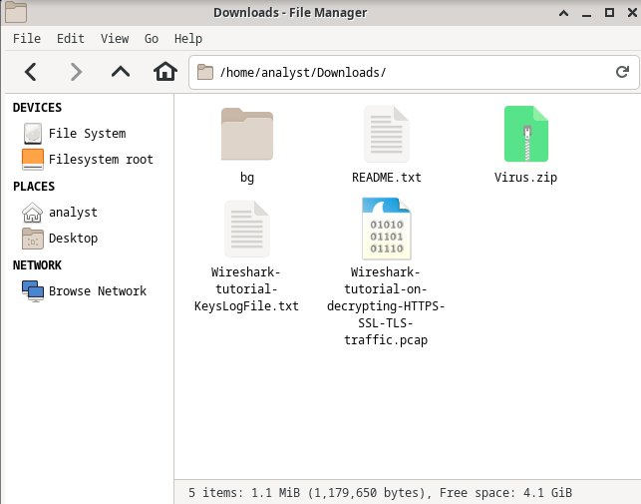
Evidence 2: Uploaded and working PCAP file (1 Point) | 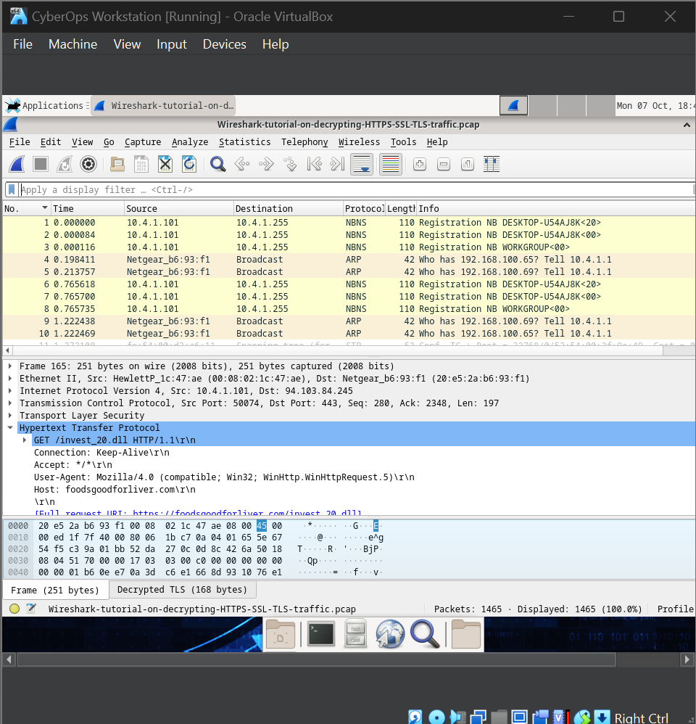
Evidence 3: Showing command are working (http.request or tls.handshake.type eq 1)and(ssdp)  (1 Point) | 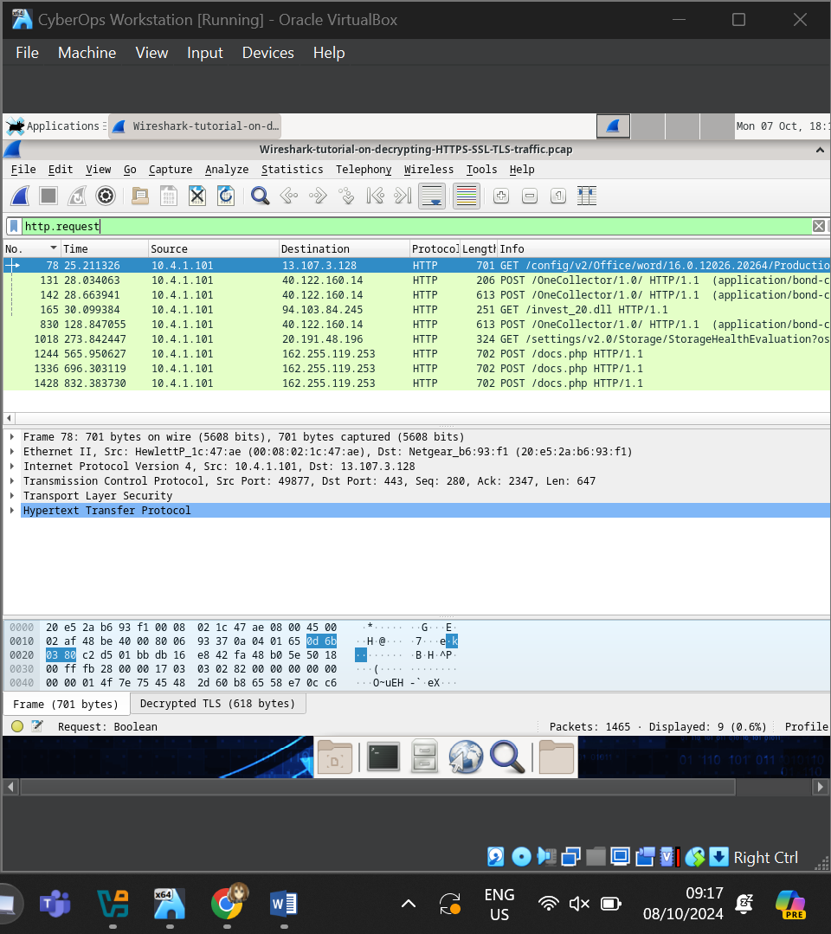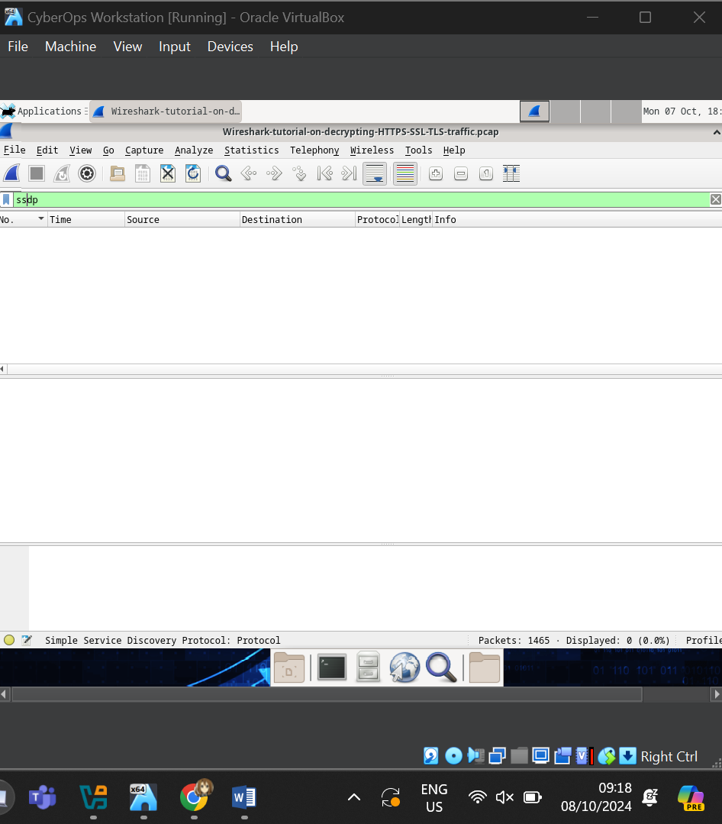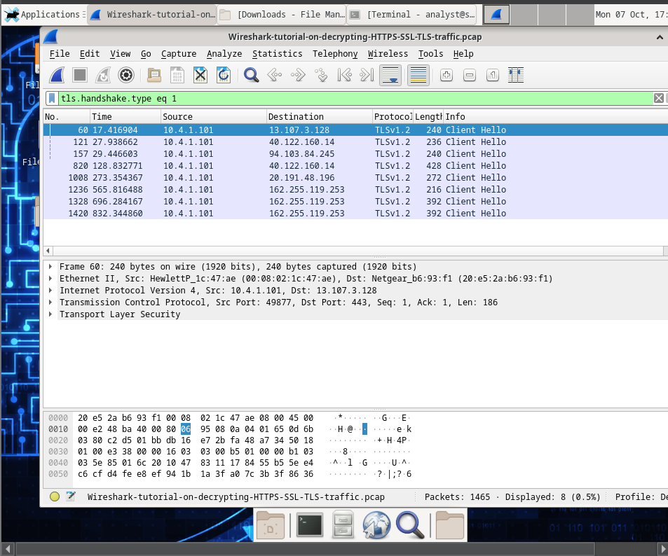
Evidence 4: Filter the llists of HTTP and TLS Protocol sorted (1 Point) | 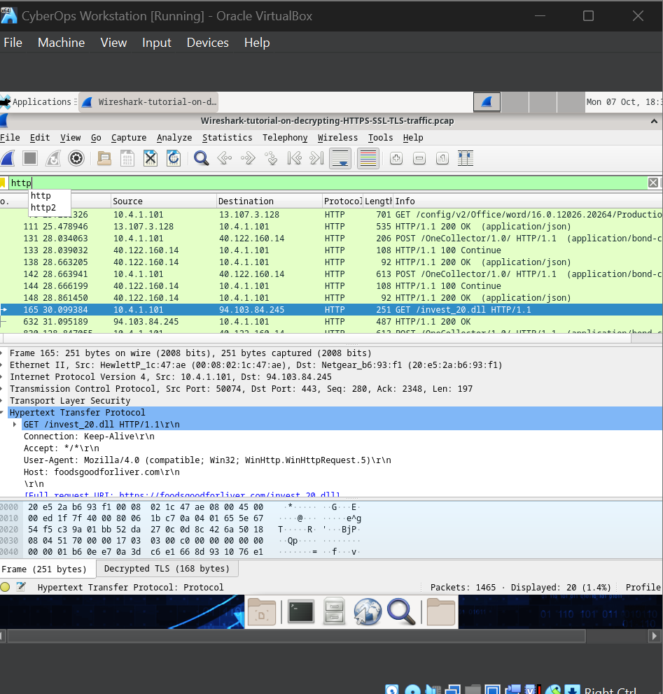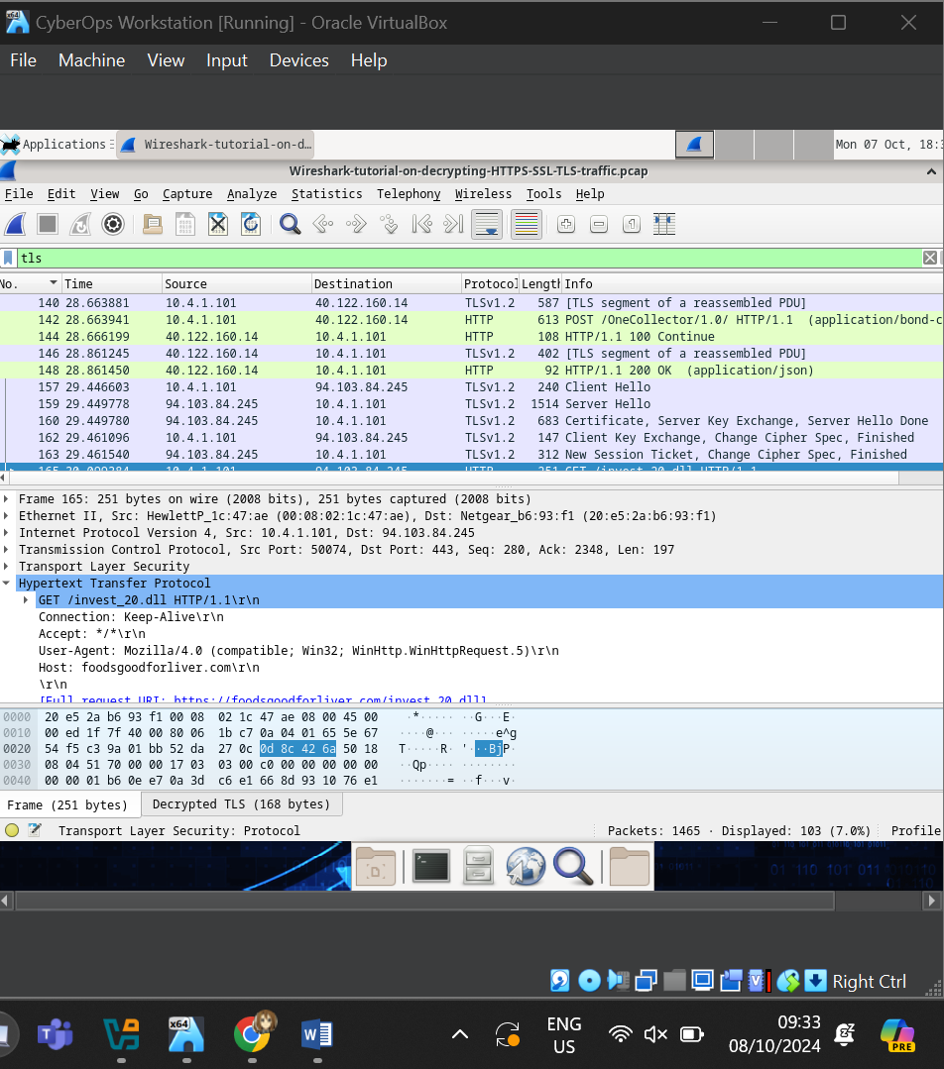
Evidence 5: Identify infected host (1 Point)
Evidence 6: Alerts, Locating the website that the malware downloaded (1 Point) | 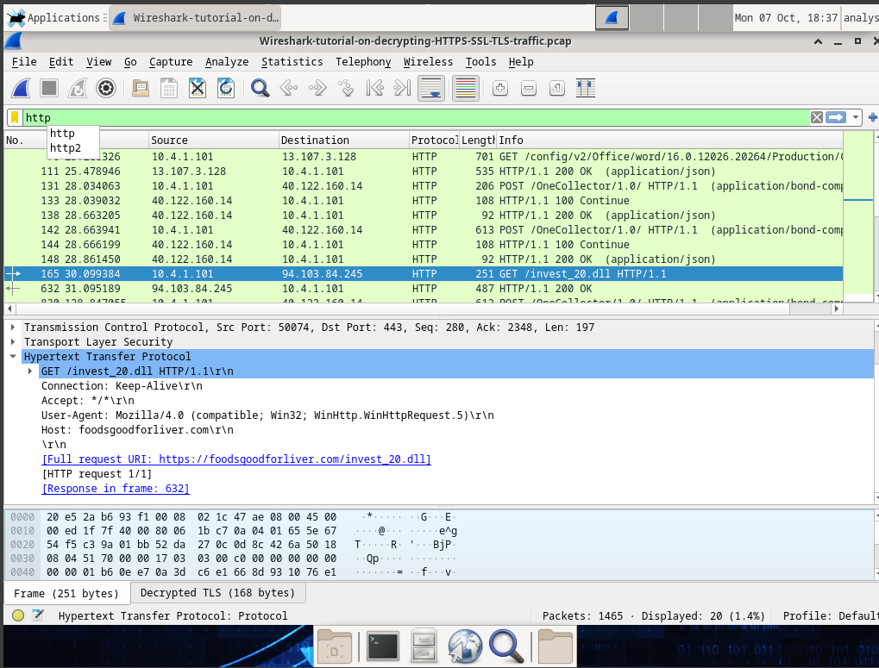
Evidence 7: Verifying the malware site thru HTTP streams (1 Point) | 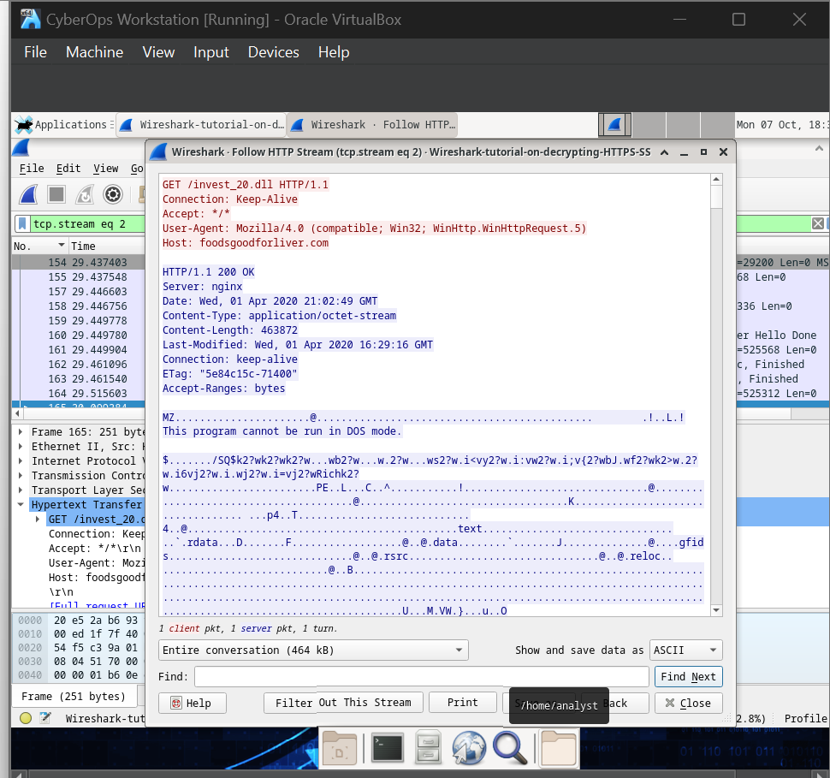
Evidence 8: invest_20.dll file exported (1 Point) | 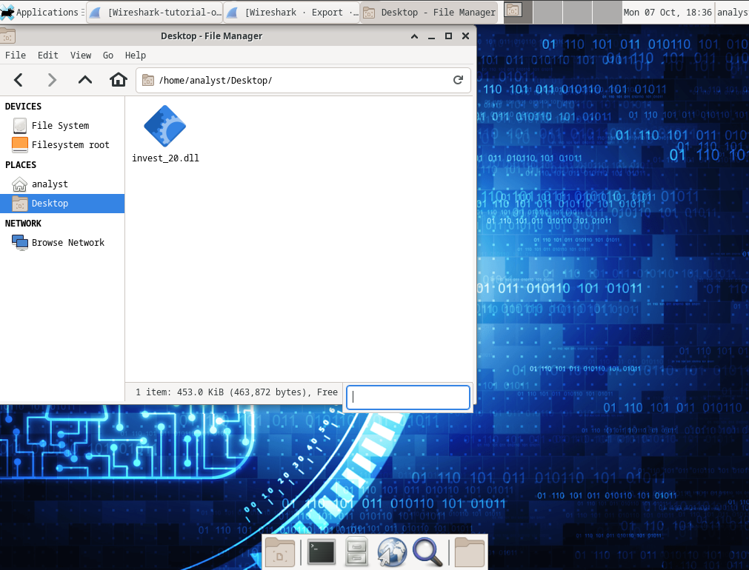
Evidence 9: Locate the file name and determine the SHA 256 hash. (1 Point) | 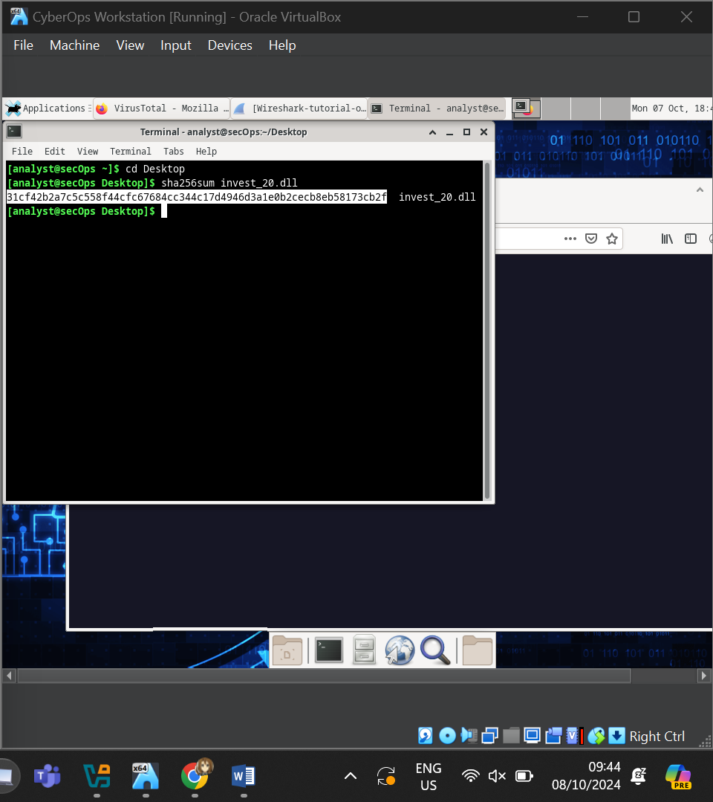
Evidence 10: Show the web information and community score (1 Point) | 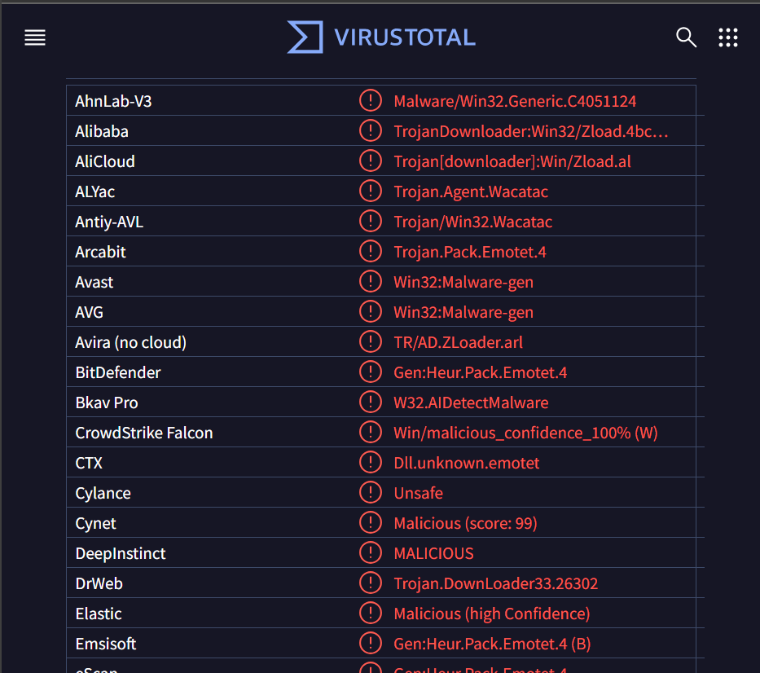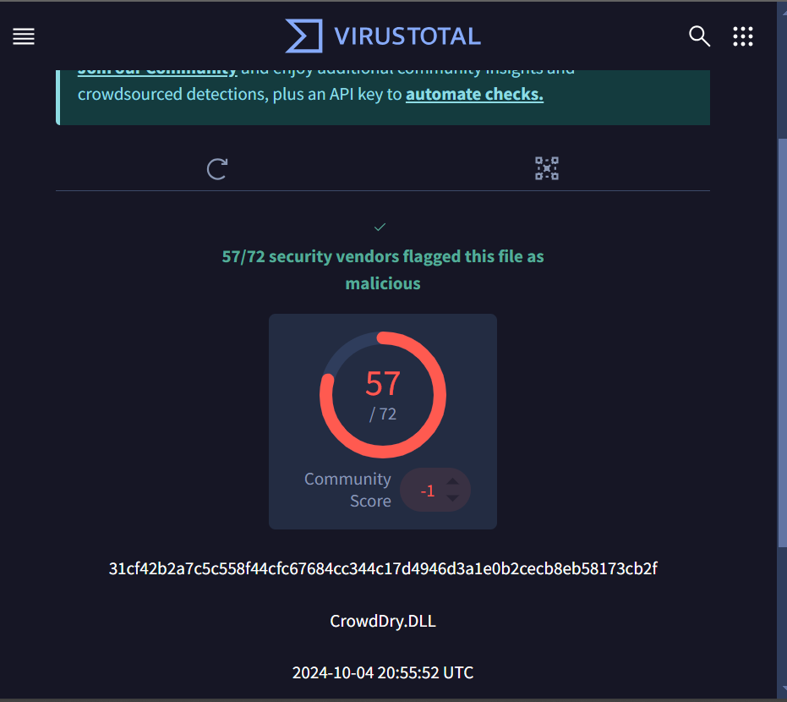

Final Score
Part 1: / 20
Part 2: / 60
Part 3: / 10
Part 4: / 10
Points: _________ of 100
Instructor Sign-off: ______________________

